Lesson Plan 10
Lesson 10: Creating a Universal Object for Making its Copies. Working with GUI (Graphical User Interface) (2 hours)
Welcome to the tenth lesson of our Roblox course! Today, we will move to a new and exciting stage - creating universal objects and working with GUI (Graphical User Interface).
In this lesson, you will learn to create unique objects with embedded scripts, which can be easily moved and copied while ensuring the scripts continue to function error-free.
Furthermore, we will delve deeper into working with GUI in Roblox. You will learn how to display the current count of objects collected by the player, as well as create congratulatory inscriptions and other interactive interface elements. These skills will help you create more interesting and interactive games, enhancing the user's gameplay experience.

1. Introduction and Homework Review (10 minutes)
Greetings, attendance check, and discussion of the homework. Give an opportunity for those who wish to present their projects.
2. Creating a Universal Object for Making its Copies (45 minutes)

2.1 Adding an Object
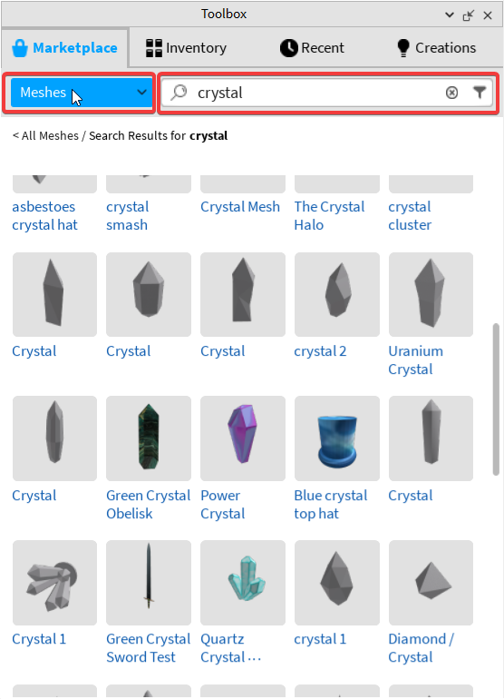
First, select an object from the Toolbox. Go to the dropdown menu and select the "Meshes" filter. Then, enter the word "crystal" in the search bar to find crystal models. Examine the available options and choose a suitable one, for example, this one.
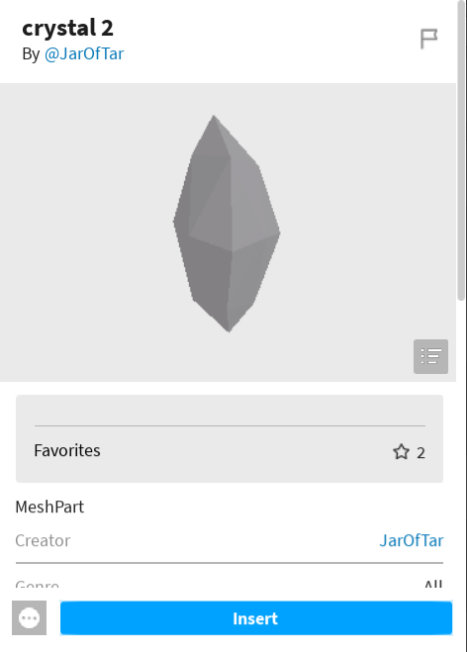
After selecting the model, add it to our workspace.

2.2 Adding a Script Using script.Parent
Now let's choose an appropriate color and material for our model and add a script to it. We will write the script in such a way that it works independently of the object's location. This means that the script will function correctly wherever we move the object, and when a copy of this object is created, the script on the new object will also work without changes.
We already know that we can find an object by moving from top to bottom, starting from the very top level, like game.workspace.Item. However, it is also possible to search for an object from the bottom up, starting with the script.
For this, the reserved word "script" is used. For example, if we write:
local parent = script.Parent
then the variable parent will store the object in which this script is located. We will use this approach to write our script.
The logic of the script will be as follows. When touched, a function will be executed, the purpose of which is to create an effect as if the player has picked up the object. Previously, we used invisibility and the property CanCollide = false for this. However, there is a simpler way: if we need to remove an object from the workspace and it will not be used in the future, we can apply the :Destroy() method to it. When this method is called, the object is destroyed and disappears from the scene.
Destroy() in Roblox is a method. Methods perform specific actions with objects, while events respond to changes or actions. The Destroy() method is used to remove an object from the game world. It is called with a colon :, which is a syntactic device in Lua for calling methods on objects.
We will also need a global variable to store the number of collected crystals and a global function that will be called when we collect a crystal. Add the following global variable and global function to the main script, located in the root of the workspace (which we created in previous lessons or create it anew):
_G.countCrystals = 0
_G.updateCount = function ()
end
The global function should be empty for now; we will write its contents in the second part of the lesson.
The script inside the crystal object will be as follows:
local parent = script.Parent

function touch()
_G.countCrystals = _G.countCrystals + 1
parent:Destroy()
_G.updateCount()
end

parent.Touched:Connect(touch)
If any of the students cope with this task faster than the others, I suggest trying an additional task: add a function with an infinite loop that will be implemented inside the same script. The goal of this function is to create a levitation effect for our crystal. This can be an up-and-down movement or rotation in a circle, which will add dynamics and animation to the object.

The solution to this task can be implemented as follows:
function levitation()
local step = 0.2
local waitTime = 0.08
while true do
for i = 1, 10 do
parent.Position = parent.Position + Vector3.new(step,step,0)
wait(waitTime)
end
for i = 1, 10 do
parent.Position = parent.Position + Vector3.new(-step,step,0)
wait(waitTime)
end
for i = 1, 10 do
parent.Position = parent.Position + Vector3.new(-step,-step,0)
wait(waitTime)
end
for i = 1, 10 do
parent.Position = parent.Position + Vector3.new(step,-step,0)
wait(waitTime)
end
end
end

levitation()

2.3 Copying the Object and Placing All Its Copies in a Separate Folder

Once the script for the object is fully ready, we move on to the next step - creating copies of our object. You will need to create 5 copies of this object and place them in the workspace. To create a copy, simply right-click on the object and select "Duplicate" from the dropdown menu.

It is particularly important to note that when copying an object, all its functionalities, including the script, are copied. This means that when the game is launched, the script will automatically work for all copied objects. Thus, you can quickly and effectively spread the functionality of one object to many, significantly simplifying the game development process.
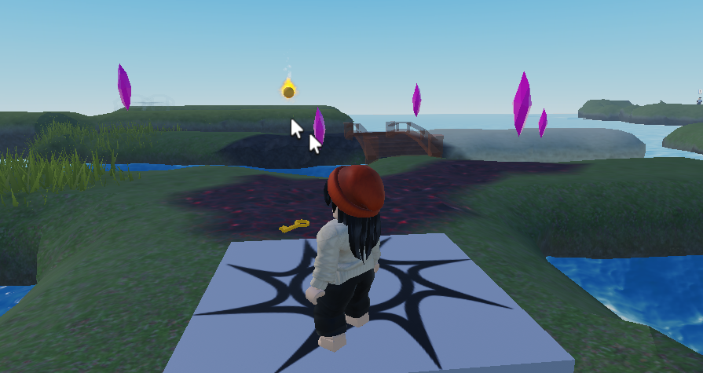
Now that we have several crystal objects in our workspace, it's time to organize them. To avoid cluttering the workspace, let's create a folder specifically for storing all our crystals. For this, click on the "+" sign next to Workspace and select "Folder" from the list.
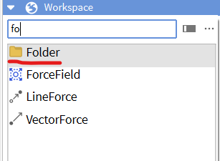
After creating the folder, move all the crystal objects into it. This placement will help maintain order in your workspace, allowing you to expand and collapse the folder for convenient access to the objects. We can name the folder "Crystals" to immediately understand what's inside.
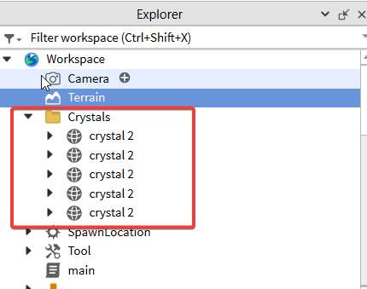
It's important to note that moving the crystals into a folder will not affect the operation of the scripts embedded in them. Despite the change in the path from Workspace to the crystals, the scripts will continue to function as before.

3. Break (10 minutes)

4. Working with GUI (Graphical User Interface) (50 minutes)
GUI, or Graphical User Interface, is an important part of most video games. To better understand what it is, imagine you are looking at the game world through transparent glass. On this glass, some opaque information is displayed - this is the GUI.
This interface includes elements that show the player important information, such as the number of lives, points, ammunition, and other data necessary for gameplay. The Graphical User Interface is designed to present this information in a convenient and easily readable format, without distracting from the game itself.
GUI helps players quickly navigate statuses and resources available in the game, making the gameplay process more intuitive and immersive.

4.1 Working with GUI
To start working with the Graphical User Interface in Roblox, first click on the "UI" menu item, which is located on the "HOME" tab.
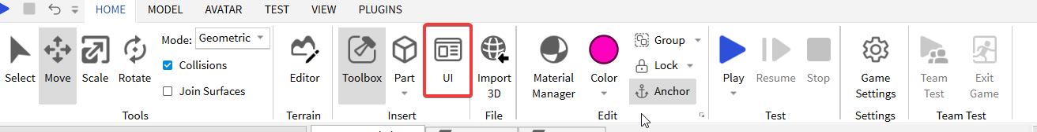

After that, a new tab will open. Click on the "ScreenGUI" menu item.
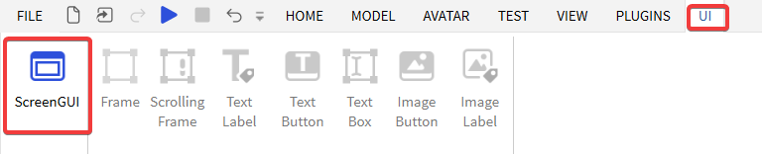
As a result of this action, a new "ScreenGUI" object will appear in the "Explorer" window, and the rest of the interface tools will be activated.
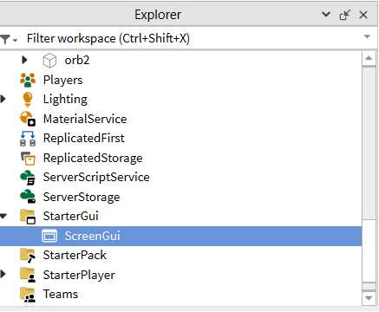

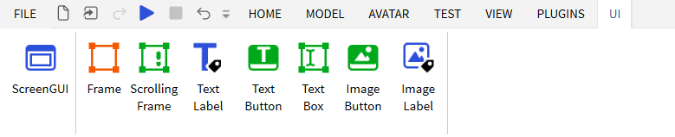

4.2 Text Labels
Now, let's add two labels. Use the "Text Label" tool for this.

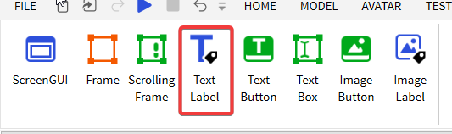
Place the two panels with labels next to each other on the screen.
In the "Explorer" window, rename the second panel with the label to "TextLabel2". This will help you navigate the structure of your interface more easily.
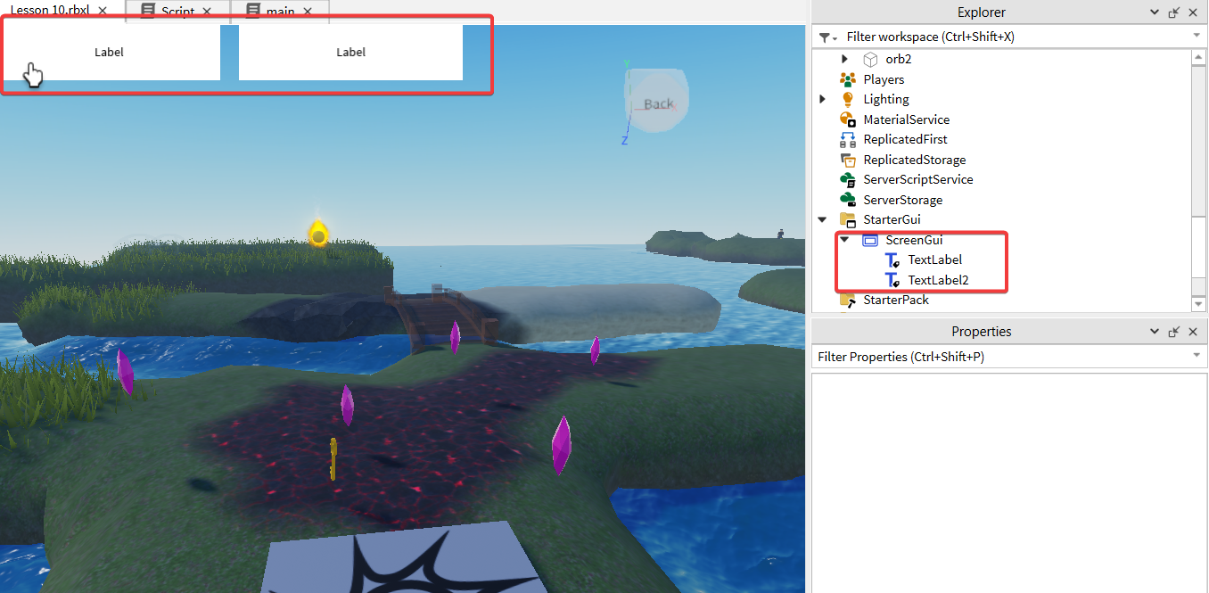
TextLabel objects have many properties related to their appearance. Here is a brief description of the most useful properties:
- Visible: Determines whether the text label is visible. This property can be used to turn text labels on and off.
- BackgroundColor3: Determines the background color of the text label. The value is set in RGB format.
- BackgroundTransparency: Sets the transparency of the text label's background. Values range from 0 (opaque) to 1 (completely transparent).
- BorderColor3: Sets the color of the text label's border. The value is also set in RGB format.
- BorderSizePixel: Determines the thickness of the text label's border in pixels.
- Font: Sets the font of the text. Roblox supports various fonts that can be selected from a list.
- Text: Contains the text displayed in the text label.
- TextColor3: Determines the color of the text, set in RGB format.
- TextSize: Sets the size of the text in points.
- TextScaled: When this property is set to true, the size of the text automatically scales to fit the dimensions of the text label.
- TextStrokeColor3: Determines the color of the text stroke.
- TextStrokeTransparency: Sets the transparency of the text stroke, with possible values ranging from 0 (opaque) to 1 (completely transparent).
To set up the appearance of the labels in Roblox, you will need to perform the following steps:
- Set the BackgroundTransparency property to 1 to make the background of the text label completely transparent. This will remove the visible background behind the text, making it appear to "float" on the game screen.
- Activate the TextScaled option. This automatically scales the text to fit within the boundaries of the text label, regardless of its size. The text will increase or decrease to fit the space allocated for the label.
- Set the desired text color using TextColor3, specifying values in RGB format. For example, for white color, enter [255, 255, 255], and for other colors, the corresponding RGB values.
- In the Text property, enter the text that should be displayed on the label. For the first label, enter "Crystals:", and for the second one - "0". This will set the content of the text labels that will be displayed on the screen.
- Adjust the sizes and positions of the labels for a nice display.
After completing these steps, you will have two text labels with the desired settings: the first will display the word "Crystals", and the second - the number "0", both with a transparent background and automatically scaled text.
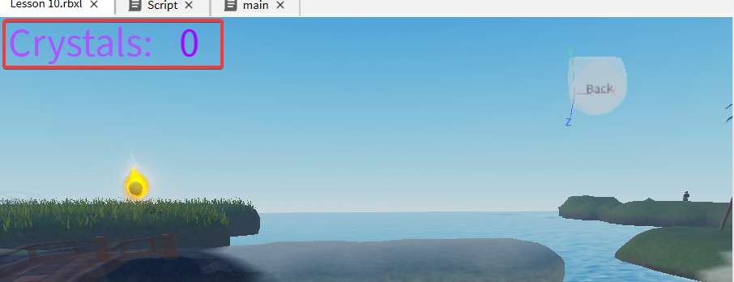

4.3 Displaying the Number of Collected Objects
This part is the most complex, but it is necessary to provide an example of updating data in text labels. I have explored different ways to solve this task and concluded that there is no simpler way than using events. The problem is that only a script directly in the GUI can update data in the GUI.
Therefore, we need to somehow initiate the code inside the GUI.
For this, we will use events. If the children remember, we studied events in Scratch.
The essence of working with events is this: an event is initiated in one place, and code anywhere, any object, can subscribe to this event and trigger processing. In simpler terms, if we launch an event in one place, then in another, we can react to this event. This is how we link different parts of the code.
But today we will work with events as a kind of magic, not delving into the details of their inner workings.
So, let's start.

4.3.1 Creating an Event
First, let's create an event. For this, we go to the ReplicatedStorage container, which is a special storage in Roblox. ReplicatedStorage is used to store data and objects that must be accessible both on the server and on all client devices, ensuring their synchronization in multiplayer games.
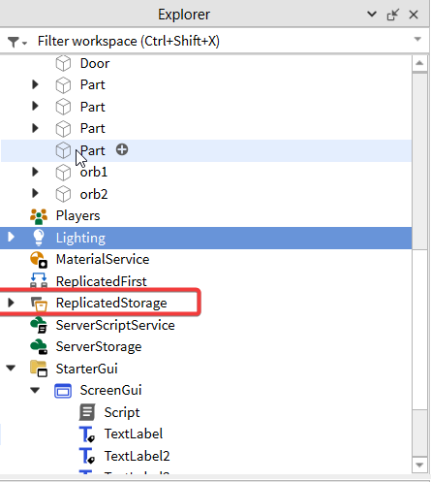
Using the plus button on this container, we create a new object inside ReplicatedStorage. We need a BindableEvent object.
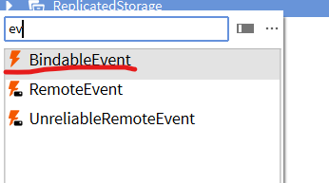
This object is used to create custom events that are not built into standard Roblox objects. A BindableEvent can be "invoked" from one part of the code and "subscribed to" in another, allowing different scripts to communicate with each other.
After creating the object, we rename it to CountChanged. This will be the name of our event, and now we have the following structure:
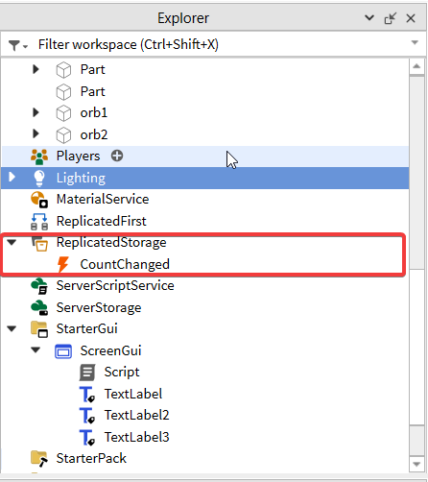
Now that we have a BindableEvent, we can use it to notify all subscribers about an event, such as a change in the number of collected items in the game.

4.3.2 Initiating the Event
The next step is to initiate the "CountChanged" event. For this, we refer to the _G.updateCount function in the main script, which we created earlier and left empty. Inside this function, we now initiate the "CountChanged" event.

_G.updateCount = function ()
game.ReplicatedStorage.CountChanged:Fire()
end
At this stage, a common error is encountered: using a dot instead of a colon when calling the Fire() method. To properly initiate the event, it is necessary to use a colon, as we are calling a method of the object.

4.3.3 Reacting to the Event
The last step is to react to the event. For this, we will add a script to the StarterGui -> ScreenGui container.
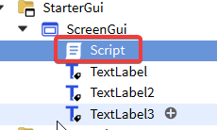
The script will be organized as follows:
local label = script.Parent.TextLabel2
function changeLabel()
label.Text = _G.countCrystals
end
game.ReplicatedStorage.CountChanged.Event:Connect(changeLabel)
In this script, there are several important points to note:
- local label = script.Parent.TextLabel2: Here, we start with the script object and move up a level to find the parent container, and then move down a level to find the TextLabel2 text label.
- game.ReplicatedStorage.CountChanged.Event:Connect(changeLabel): We find the CountChanged event object in ReplicatedStorage and subscribe to its Event. This event will trigger the changeLabel function when it is initiated.
These steps help us link an event occurring in one part of the game with actions in another part, ensuring interaction between the server and the user interface.

4.4 Examining the System Reaction Process
Let's step by step go through the system's reaction process, starting from collecting an object in the game and ending with changing the counter in the user interface:
- When an object is touched in the game, the touch() function inside this object is activated. This function increases the value of the global counter and calls the global _G.updateCount() function.
- The global _G.updateCount() function is responsible for initiating the CountChanged event. This is done to inform the rest of the game about the change in the counter.
- The CountChanged event is intercepted by a script located in ScreenGui. This script reacts to the event, launching the changeLabel() function.
- The changeLabel() function updates the text on the text label, using the current value stored in the global variable. This leads to a change in the displayed counter in the user interface.

Thus, the entire system is connected through a series of events and functions, ensuring synchronization between the gameplay process and the user interface.

4.5 Message Congratulating on Winning the Game
As a final touch, let's add a congratulatory message to the game, which will be displayed when collecting 5 objects.
The process of creating this inscription is similar to what we did with the previous text labels:
1. In the ScreenGui container, add a TextLabel object and rename it to TextLabel3.
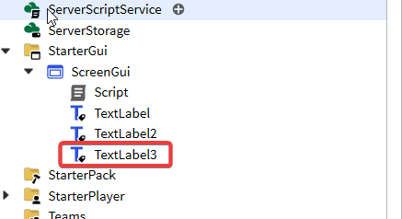
2. Change the properties of this label to suit your preferences. For example, you can adjust parameters such as text color, font, size, etc. You might want to make the text bold and add a white outline around the text to make it stand out on the screen.
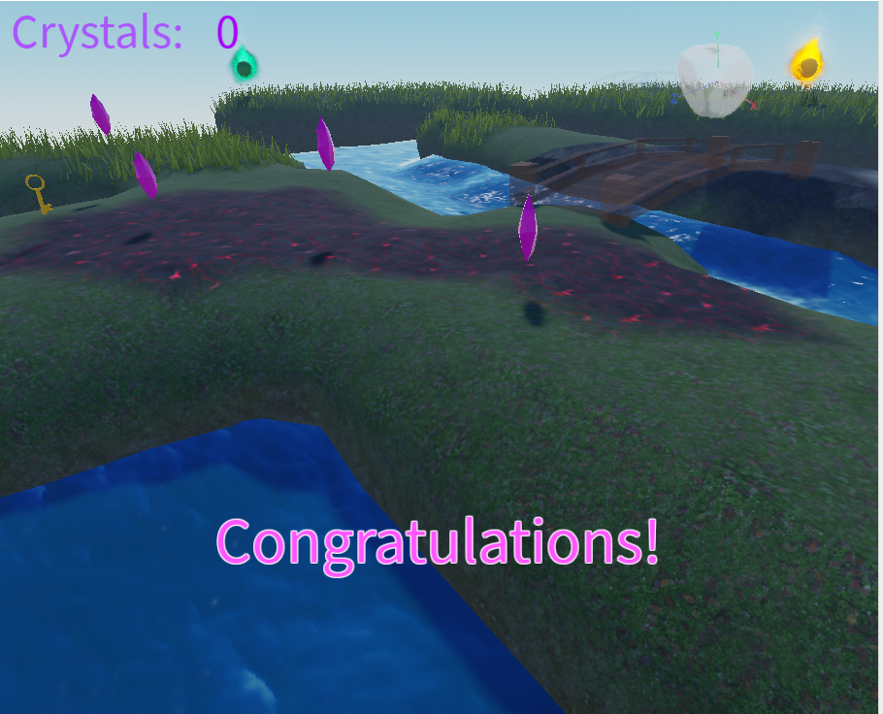
The screenshot below will highlight the properties you can use to achieve the desired appearance of the text, including boldness and outline. These settings will help make the congratulatory message more noticeable and attractive to players.

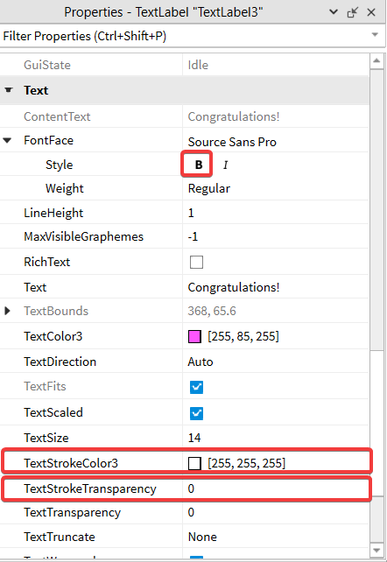
After you have set up the appearance of the label, it is necessary to place it correctly on the game screen. Do the following:
1. Place the label in the desired location on the game screen. This is an important step, as the visibility and perception of the label by players depend on its position.
2. Hide the label by unchecking the `Visible` property. As a result, the label will become invisible in the game but will remain accessible for programmatic control.
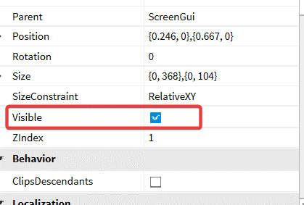
Now, to display this label in the game, simply change the `Visible` property by setting its value to `true`. For this, you need to modify the script in `ScreenGui` so that the congratulatory label appears as soon as the player collects 5 objects. You can use a condition in the code that checks the number of collected objects and makes the label visible when the required number is reached.
Here is the final version of this script:
local label = script.Parent.TextLabel2
local congrats = script.Parent.TextLabel3

function changeLabel()
label.Text = _G.countCrystals
if _G.countCrystals == 5 then
congrats.Visible = true
end
end

game.ReplicatedStorage.CountChanged.Event:Connect(changeLabel)

5. Feedback (5 minutes)
At the end of the lesson and upon completing independent tasks, it's important to gather feedback from the students. This helps to understand not only what was most useful and interesting for them but also to identify areas that may need improvement or further explanation.
Idea for conducting a feedback session:
Positive Point: Ask the children to take turns sharing what they liked most during the lesson. This could be a specific tool, effect, or just the general teaching approach.
Area for Improvement: Also, invite students to express what they did not like or what they think needs to be improved. This could be the complexity of the material, pace of teaching, or some technical aspects.
Summary: After everyone has spoken, draw conclusions. Note the general trends in the feedback and discuss what changes or improvements could be introduced in future lessons.
The feedback session is a valuable tool for the teacher, as it provides specific information about how the lesson was perceived by the students. This can also be a motivating factor for the children, as they see that their opinions are taken into account.

